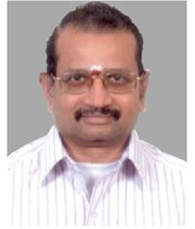

Message from the Secretary
I am very glad to welcome 1984 batch students of CIT back to CIT Campus. Quarter of a century is a long time and you all must have earned lots of laurels and progressed successfully in your life.
Silver jubilee reunion is the most appropriate opportunity to unite and share your experiences with your college mates and their family members. This is an opportunity to renew broken contacts and introduce the family to fellow mates of yester years. I am sure that these two days of rejoice will have lasting wonderful impression in your and your family members for times to come. This will also be an opportunity to develop new family & business contacts which may be extremely useful in the future.
I wish you all a wonderful time during the reunion. Best of wishes for a successful and happy future.

Dr.R.Prabhakar
Secretary

