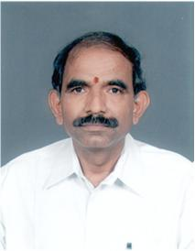

Message from the Principal
I am happy to note that 1984 batch of Coimbatore Institute Technology is celebrating its Silver Jubilee Reunion to mark the 25th year of passing out from this Institution. The freedom and flexibility enjoyed by you in the campus has shaped you as the leading professional occupying good position around the globe. The reunion will pave a way to improve the networking of family to exchange new ideas and future planning. I wish good luck and bright future for the 1984 batch students and their families.
ALL THE BEST.
Dr.V.Selladurai,
Principal

