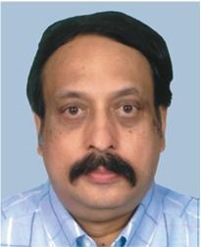

Message from the Correspondent

As an alumnus of CIT I know how wonderful it is to meet old college-mates with their family members after a long gap of twenty five years. It is always important to remember where it all started from and the silver jubilee reunion is the most appropriate form of celebrating the completion of 25 years of first graduation and saluting the alma-mater.
I expect this reunion will trigger more interaction between the alumni & alma-mater heading the more useful, lasting and mutually beneficial activities.
I am confident that this reunion will have lasting impression in your mind which you will cherish for years to come. Good luck to you all & God bless you.

Dr.S.R.K.Prasad
Correspondent

