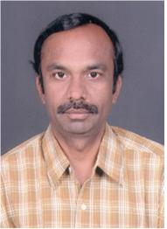

Message from the Administrative Officer
I am very glad to see that 1984 batch of Coimbatore Institute Technology is celebrating its Silver Jubilee Reunion to mark the 25th year of passing out from this Institution. It will be quite interesting to see the batch mates after a gap of 25 years. The meeting will provide a platform to exchange your ideas and plan for the future activities.
I wish all of you and your family members a bright, healthy and prosperous future and grand success in all your future endeavors.

Dr.S.Shanmugam

Administrative Officer

